Networking Task 02: Network Devices & IP Addressing
Part A: Network Devices Research
Research and explain the following network devices in your own words:
1. Router
Purpose: Connects different networks and directs data packets between them.
How it Works: A router receives data from one network and forwards it to the correct destination using IP addresses.
Real-World Usage: Home Wi-Fi routers connect devices to the internet.

2. Switch
Purpose: Connects multiple devices within the same network.
How it Works: A switch uses MAC addresses to send data only to the intended device.
Real-World Usage: Used in offices, schools, and computer labs.

3. Hub
Purpose: Connects multiple devices in a network.
How it Works: A hub sends incoming data to all connected devices without checking the destination.
Real-World Usage: Older networks; rarely used today because switches are more efficient.

4. Access Point (AP)
Purpose: Provides wireless network access to devices.
How it Works: Connects wireless devices to a wired network using Wi-Fi signals.
Real-World Usage: Wi-Fi hotspots, offices, schools, and homes.

5. Firewall
Purpose: Protects a network from unauthorized access and threats.
How it Works: Monitors incoming and outgoing traffic and blocks suspicious activities.

Real-World Usage: Used in organizations and personal computers for security.

6. Modem
Purpose: Connects a network to an Internet Service Provider (ISP).
How it Works: Converts digital signals from a computer into signals that can travel through telephone, cable, or fiber lines.
Real-World Usage: Internet connections in homes and offices.

Part B: IP Address Classification
Identify whether the following IP addresses are Public or Private:
IP Address | Public/Private | Reason
192.168.1.10 | Private | Falls within 192.168.0.0 – 192.168.255.255 private range
10.0.0.5 | Private | Falls within 10.0.0.0 – 10.255.255.255 private range
172.16.5.20 | Private | Falls within 172.16.0.0 – 172.31.255.255 private range
8.8.8.8 | Public | Google's public DNS server
1.1.1.1 | Public | Cloudflare's public DNS server
192.168.100.1 | Private | Falls within 192.168.0.0 – 192.168.255.255 private range

Part C: Understanding Your Network
Find:
• IPv4 Address
• Default Gateway
• DNS Server
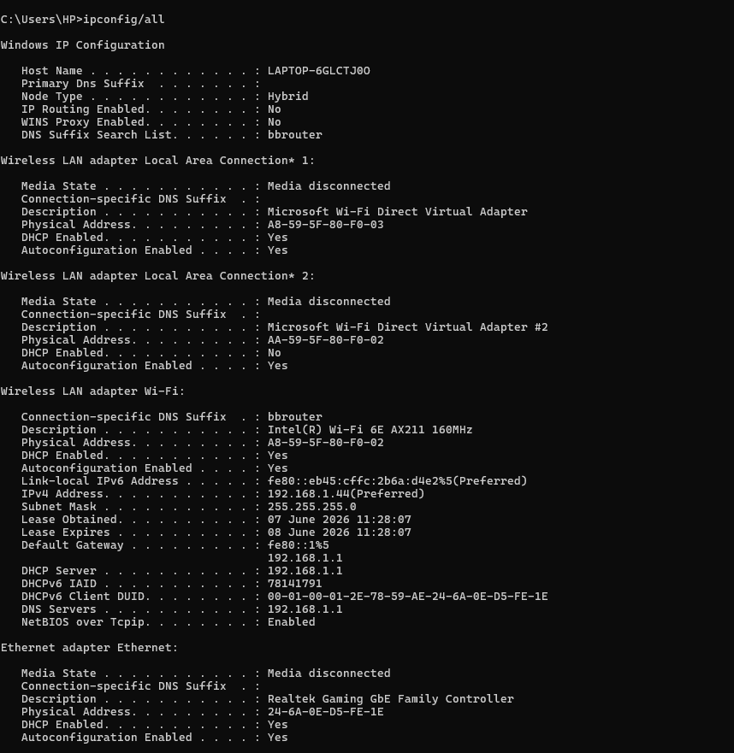

Answer:
1. Which IP range does your device belong to?
My device belongs to the 192.168.1.x range.
2. Is it Public or Private?
It is a Private IP Address because it falls within the 192.168.x.x private range.
3. What role does your router play in your network?
The router connects my local network to the internet and directs data packets between devices and external networks.
4. What would happen if the DNS server stopped working?
Websites would not open using domain names because the DNS server translates domain names into IP addresses. Users would need to access websites using IP addresses directly.

Part D: Network Communication Flow
Create a simple diagram showing what happens when you open:
www.google.com
Example:
Your Device ↓ Router ↓ DNS Server ↓ Google Server ↓ Response Back to Device
Explain each step in 2–3 lines.
Step 1: User Request
When a user enters www.google.com in a browser, the computer sends a request.
Step 2: Router
The router forwards the request from the local network to the internet.
Step 3: DNS Server
The DNS server converts the domain name (www.google.com) into an IP address.
Step 4: Google Server
The request reaches Google's server using the obtained IP address.
Step 5: Response
Google's server sends the webpage data back through the internet and router to the user's device.

Part E: Practical Command Exercise
Windows
Run:
ipconfig /all
nslookup google.com
ping google.com



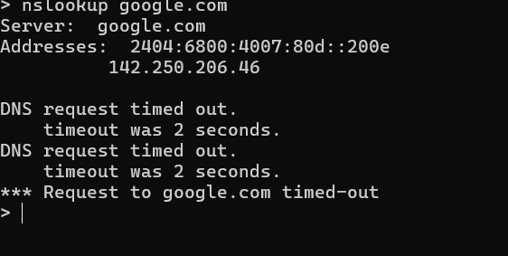

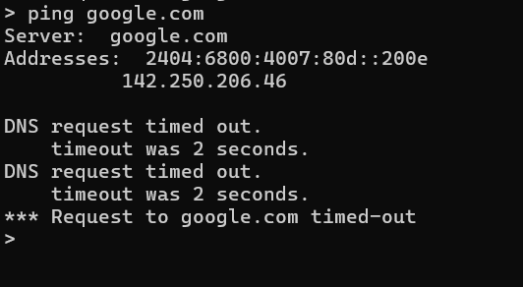

1. What IP address did DNS return for Google?
142.250.193.78
2. Was the ping successful?
Yes, the ping was successful if replies were received from Google.
3. Why is DNS important before communication begins?
DNS converts human-readable domain names into IP addresses that computers use to communicate over the internet.

